**Name: __________________________  
Date: ___________________________**

**Lesson 2-10: Composition of 3D Figures**

**Learning Goal: #15: How do I find volume of a composite figure??**

**Definition:** **A *composite figure*** is a shape that can be made up of any of our 3-D figures __________________!

**Let’s try one together!**

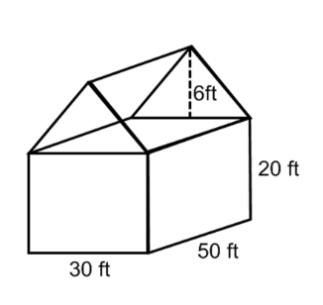The Miller's want to heat their house from top to bottom. The house is made up of a triangular prism and a rectangular prism. Find the total volume of the house that will be heated to the nearest cubic foot.

------------------------------------------------------------------------------------------------------------------------------------------

**Turn and Talk**

**Summarize the steps we used to solve the composition problem?**

**Steps to Follow**

1. Calculate the ___________________ of _______________________
2. Calculate the ___________________ of _______________________
3. Combine the volumes together by __________________________________

**How would our approach be different if they asked us to find the total surface area? How would it be the same?**

 **Watch me!**

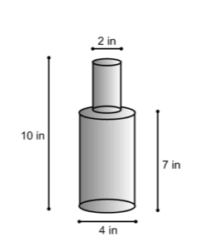**1.** Beth got a new bottle for her homemade salad dressing. How much salad dressing to the nearest hundredth of an inch can she fit in the bottle if she fills it to the top?

***Sketch and label the two figures that make up the composite figure to the right:***

**2.** A top company has a new statue in front of their building. They want to paint it with a protective coat. How much paint will it take to cover the statue to the nearest square foot?

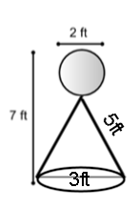

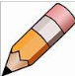 **You Try!**

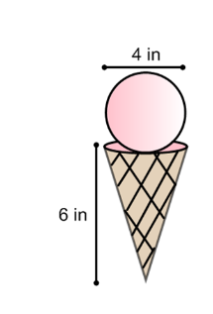**3.** How much ice cream is in this cone to the *nearest tenth*? Assuming the ice cream fills the entire cone and a scoop on top. The scoop has the same radius as the cone.

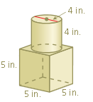**4.** Find the volume of the composite solid. Round all answers to the nearest tenth of a cubic unit.

**Name: __________________________  
Date: ___________________________**

**Lesson 2-10: Homework**

1. Find the volume of the composite solid. Round all answers to the nearest tenth of a cubic unit, when necessary.  
   ***(Sketch and label the two figures that make up the composite figure to help!)***

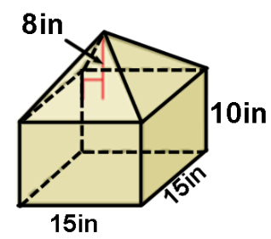

1. Reynaldo builds a pool in his backyard. The pool measures 55 feet long, 28 feet wide, and 9 feet deep. How much water will fit in the pool?
2. 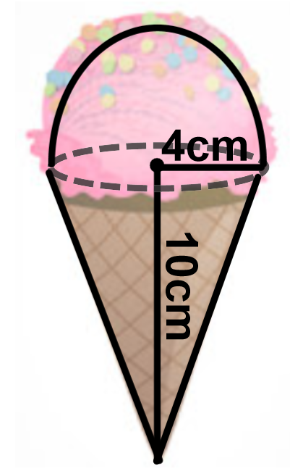Mr. Gino ate an ice cream cone filed with ice cream, and a hemisphere of ice cream on top modeled on the right. The cone has a height of 10 cm and a radius of 4 cm. Calculate the amount of ice cream that Mr. Gino ate rounded to the nearest cubic centimeter.